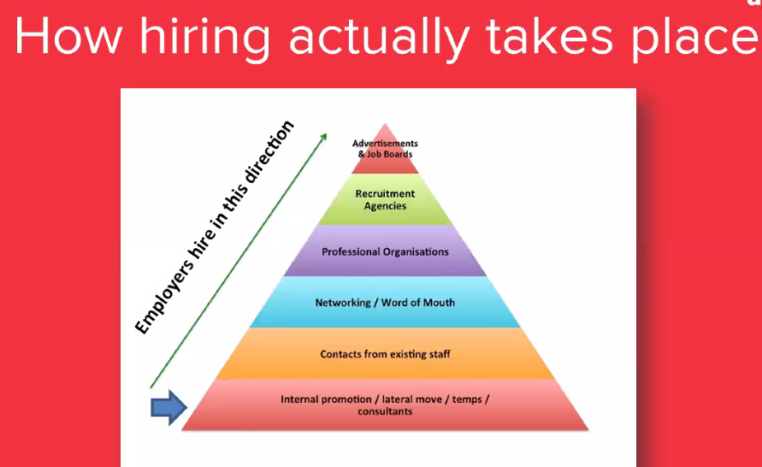





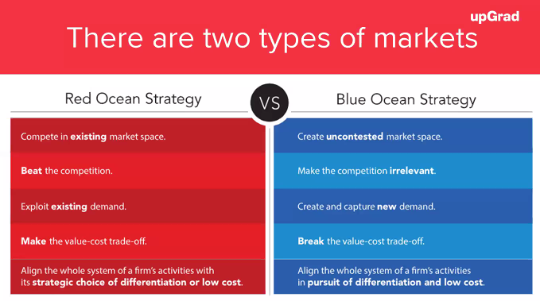

When searching for new jobs – look at 3 pillars of success

1. Target companies that are growing fastest
2. Companies that are great places to work (https://www.greatplacetowork.in/)
3. Companies that are entering the country now
4. Find a recruiter/ Talent Acquisition Manager (TAMs): India Google Recruiter / India Google India Talent Acquisition Manager
5. Send high-quality content to TAMs, ask them for an informational meet for 15 minutes with a date and time of their convenience
6. How can I contribute to the growth prospects of your company?

Leverage free services to get email ids salesql.com, getprospect.com, hunter.io, lusha

How to write to TAMs – email octopus